Wetland project expands
The Niagara Advance - November 22, 1994
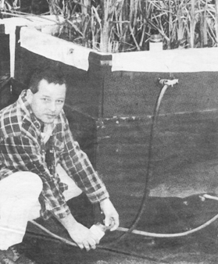

Grad Student Lloyd Rozema takes water samples from one of the
SWAMP project cells for testing.
The SWAMP began as a green alternative to the recently opened sewage treatment plant on Lakeshore Road. But, the SWAMP (sewage waste amendment process) really started when Dr. Ed Lemon came across an article in the Smithsonian magazine about a town in California, Arcata, similar in size and to NOTL, using a constructed wetland to 'polish' their sewage.
The swamp acts in the same way as the chemical treatment plant does, but without the use of chemicals. Both treatment systems take already treated sewage and remove nitrogen and phosphorous from the water. This is referred to as tertiary treatment or polishing.
"either on of them could work in tandem," Lemon said, adding if the use of chlorine in treating water is abandoned "it would be a good idea to see them working together."
"Both do the same job exactly," Tom Braybrook said, adding ht only difference is the price. It is estimated that a 10-acre wetland, which would do the same volume as the plant, would cost $1 million. The treatment plant costs more than $7 million. "A $7-million white elephant," is what Braybrook called the plant. "The solution is worse than the answer," he said, "ask anybody with a brain." Braybrook pointed to the emission of ammonia from the plant, caused during the chlorine treatment stage, which kills wildlife and is a carcinogen.
The project was initiated to study if the Arcata system could be used in a variable climate, where the water freezes in the winter. "That was the challenge - can we find a system that would work all year round," Lemon said. The problem was solved in the first year, by the introduction of the water underneath the ice through a system of piping. "We just flood below the surface of the wetland and let the surface freeze." Despite the project's success, Lemon admits there are hurdles to overcome.
"The project is not a panacea - it is not working perfectly. We are having some problems with phosphorous." The absorption by the wetland bed of phosphorous in the winter is slowed down, to about 60 per cent of capacity. The bed also has a finite life, because, like a sponge, it can only absorb so much.
The Friends of Fort George SWAMP project committee, made up of Lemon, Braybrook, Jim and Erica Alexander, Rob Copeland and Gary Burroughs, hopes the $125,000 in recently announced funding will help them get over these problems.
The money will also be used to hire, on a part-time basis, graduate students, including Lloyd Rozema, a volunteer on the SWAMP for two years who will receive his honours degree in science this spring.

